**Exercise- Data Measurement**

**Student Name: Student Id:**

**Date:**

# Please use the screenshots ONLY as a reference. The instructions have to be followed AS-IS.

# **Objective**

# We collect data to gain a better understanding of something that occurs in the universe. Data points collected evolve from observations or experiments. From these collections of data we can gain insights and draw conclusions. Observations and measurements are data created about a phenomena. Data is the reflection of a phenomena. As part of this exercise, measure the data and visualize it based on different phenomena that you have observed.

# **Examples in practice:**

You should perform the experiments and collect the data. Make up of data/obtaining the data from Internet is strictly prohibited

## **1. Science Phenomenon:**

### **Model Example**

**Note:** Treat this phenomenon as a model for your ideas and use this as a reference to answer the exercise questions

#### **Measure the height of a burning candle**

# Record the phenomenon of lighting a 10 inch (diameter 0.25 inch) candle and measure the length of the candle at every 3 minute interval.

**Procedure:-**

* Take a candle, a lighter, a measuring tape/scale, a stop watch
* Note initial dimension of candle
* Light the candle and let it burn for 3 minutes (use stop watch to check time), after 3 minutes blow out the candle
* Measure and record its length using measuring tape/scale
* Repeat this process for about 8 to 10 times and record the data

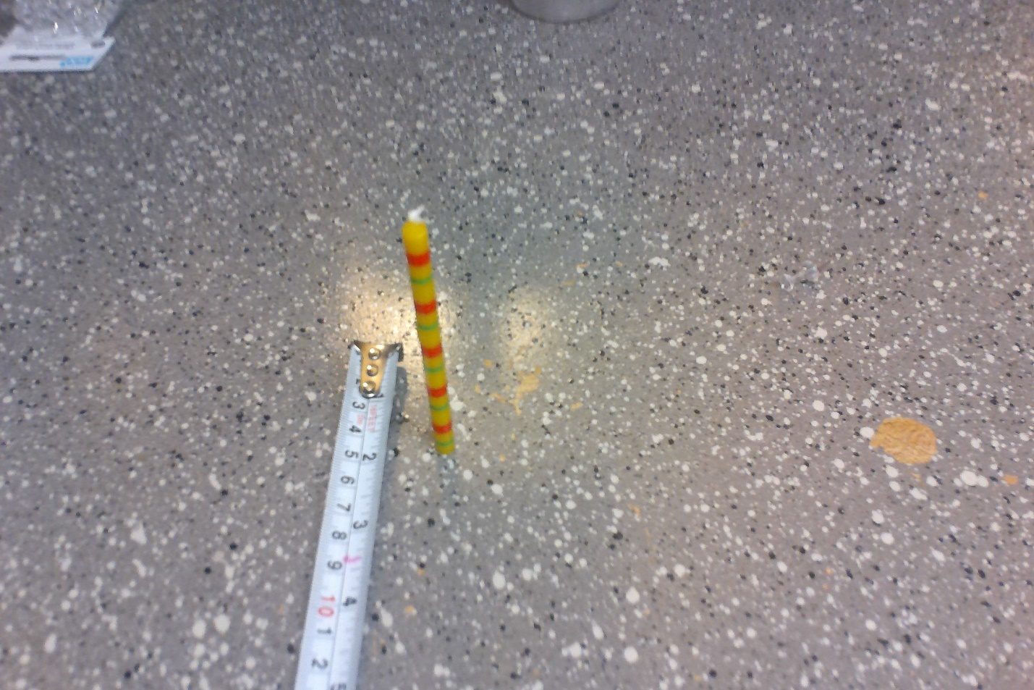

**Data Points:-**

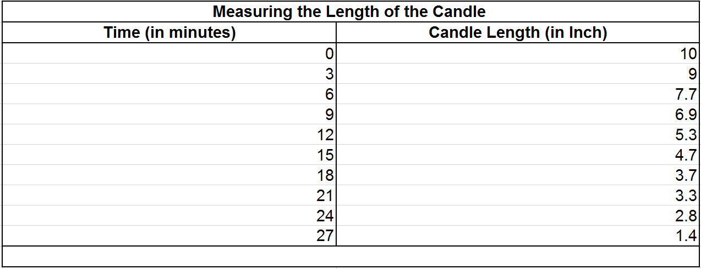

**Data Visualization:**

**Color coded data table:**

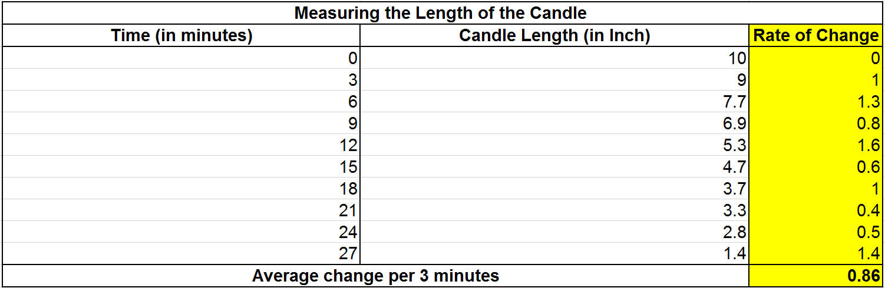

**Insights:**

1. From the graph we can infer that there is a negative linear correlation between time and length of the candle
2. Data table shows that the average change in the length of the candle in 3 minutes interval is 0.86 inches
3. Maximum reduction in the length occurred at 12th minute which was observed to be 1.6 inches
4. Minimum reduction in the length of the candle in 3 minute interval was observed to be 0.4 inches

**Other Ideas for measurement:**

#### **Measure water dispensed from a bottle with a hole:**

Record the phenomenon of measuring the water dispensed from a 500 ml bottle:-

**Procedure:**

* Take a 500ml plastic bottle, a push pin and a measuring glass
* Fill the water in the bottle and close the bottle cap
* Make a hole at the bottom of the bottle using push pin(please note- since bottle cap is tightly closed it will stop the water from flowing out of the bottle even after making the hole)
* In order to measure the amount of water dispensed from the bottle hole, open the cap of the bottle and place a measuring glass beneath it for a minute
* After 1 minute close the cap of the bottle tightly and measure the amount of water in the measuring glass
* Repeat this step until no more water can flow through the hole in the bottle

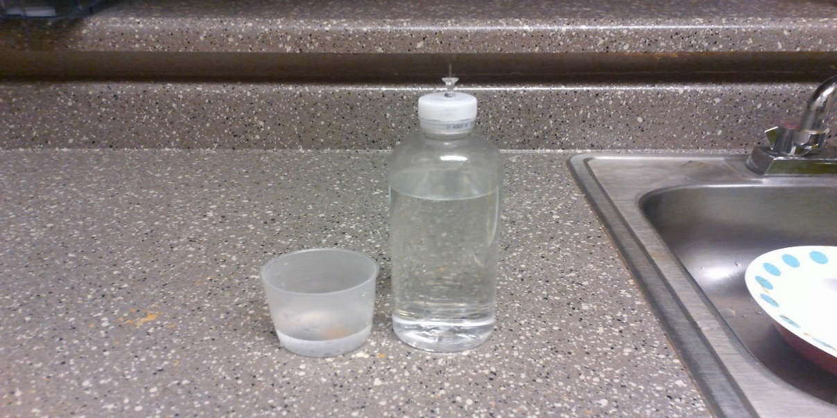

**Data Visualization:**

## **2. Business Phenomenon:**

#### **Example**

A Restaurant owner wanted to calculate the number of sodas sold every week so that he can plan his next order. This data can help in business planning

Record the number of sodas sold every week in a restaurant. Data is classified based on the Brand.

**Procedure:**

1. Record every transaction of the soda sold and its brand.
2. Count the number of soda with respect to the brand by end of every week.
3. Follow this process for 9 weeks.

**Data points:**

|  |  |  |  |  |
| --- | --- | --- | --- | --- |
| **Week** | **Coke** | **Sprite** | **Pepsi** | **Total no of soda sold in a week** |
| 1 | 120 | 90 | 40 | 250 |
| 2 | 110 | 130 | 94 | 334 |
| 3 | 104 | 122 | 83 | 309 |
| 4 | 115 | 105 | 96 | 316 |
| 5 | 90 | 142 | 120 | 352 |
| 6 | 230 | 98 | 30 | 358 |
| 7 | 110 | 145 | 70 | 325 |
| 8 | 135 | 145 | 90 | 370 |
| 9 | 95 | 172 | 100 | 367 |
| Average no of soda sold per week | | | | 331 |

**Data Visualization:**

**Color coded data table:**

|  |  |
| --- | --- |
| **Brand** | **Average no of soda sold (per week)** |
| **Coke** | 123 |
| **Sprite** | 128 |
| **Pepsi** | 80 |

**Insights:**

1. From the data table it can be observed that average no. of sodas sold in a week is 331
2. From the graph we can see that maximum number of sodas sold by a specific brand to be 230, in week 6, which is the highest by a individual brand in 9 weeks.
3. From the color coded table we can infer that the highest number of sodas sold in 9 weeks is Sprite
4. From the color coded table we can infer that the lowest number of sodas sold by Pepsi.

## **3. General Observation Phenomenon:**

**Record the total number of emails received on personal gmail account and record how many were read each day.**

**Procedure**

Record the number of emails received on personal email address for 10 consecutive days. Count and record the number of mails read each day. Following is the screenshot of how my personal email account looked like. It has the total number of emails along with the count of read and unread emails per day.

**Data points:**

|  |  |  |
| --- | --- | --- |
| Date | Emails | Read |
| 27 Aug | 42 | 13 |
| 26 Aug | 21 | 7 |
| 25 Aug | 24 | 11 |
| 24 Aug | 14 | 3 |
| 23 Aug | 17 | 6 |
| 22 Aug | 15 | 4 |
| 21 Aug | 13 | 4 |
| 20 Aug | 16 | 4 |
| 19 Aug | 21 | 10 |
| 18 Aug | 16 | 5 |

**Data Visualisation**

The following graph gives the total number of emails and the number of emails read per day.

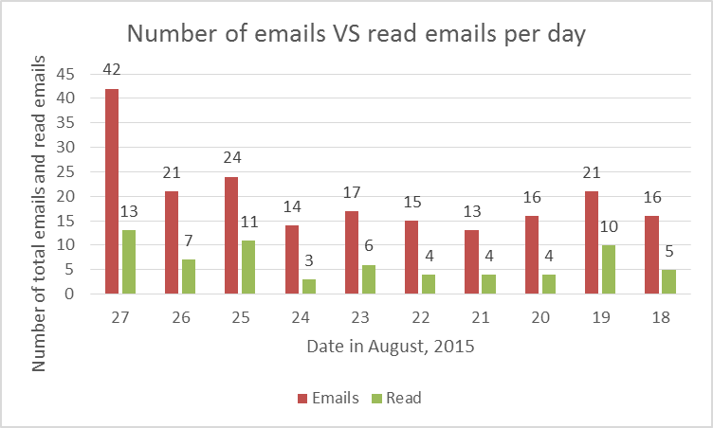

**Color coded data**



**Insights**

* An average of 20 email per day was received
* An average of 7 emails everyday was read (i.e.) 32 % of my emails was read
* On 27th august, the highest number of emails was recorded and I read the maximum number of emails also on the same day.
* I was most efficient on 19th august when I read 48% of my emails.

# **Exercise:**

Observe one phenomenon for each of the following three categories, you can refer to the above ideas however your phenomena should be different from the once highlighted above.

1. Science
2. Business
3. General Observation ( Neither Science nor Business )

Based on your observations answer the following questions for **each of the 3 phenomena** (refer to the model example for answering the following questions)

1. Describe the phenomenon and procedure in your own word. Adding pictures of your phenomena is **mandatory**.
2. Prepare a data table for the phenomenon using excel and paste the screen shot.
   1. (Note: There should be minimum 6 data points)
3. Visualize the data using excel for the phenomenon and paste the screen shot, you can use any chart that is appropriate for your data.
   1. **Note**: Please provide appropriate chart title and label to X axis and Y axis
4. Provide a color coded data table highlighting the insights, refer to ‘Color coded data table’.
5. List minimum three insights using data table, graph and color coded data table **Hint**: Check for any patterns, relationships, groupings, trends or outliers